Subject: Computing Aptitude MST LAB

**Student Name: Ayushi Aggarwal**

**Subject Code:** 21CAH654

**UID: 21MCA2806 Section/Group: 8(B)**

**Semester: 2nd Semester Date of Performance: 02/04/2022**

**MM: 6 Marks**

1.Assignment Content

WAP to PRINT FIBBONACCI SERIES.

#include <stdio.h>

int main() {

int i, n;

int t1 = 0, t2 = 1;

int nextTerm = t1 + t2;

printf("Enter the number of terms: ");

scanf("%d", &n);

printf("Fibonacci Series: %d, %d, ", t1, t2);

for (i = 3; i <= n; ++i) {

printf("%d, ", nextTerm);

t1 = t2;

t2 = nextTerm;

nextTerm = t1 + t2;

}

return 0;

}

Output of a program

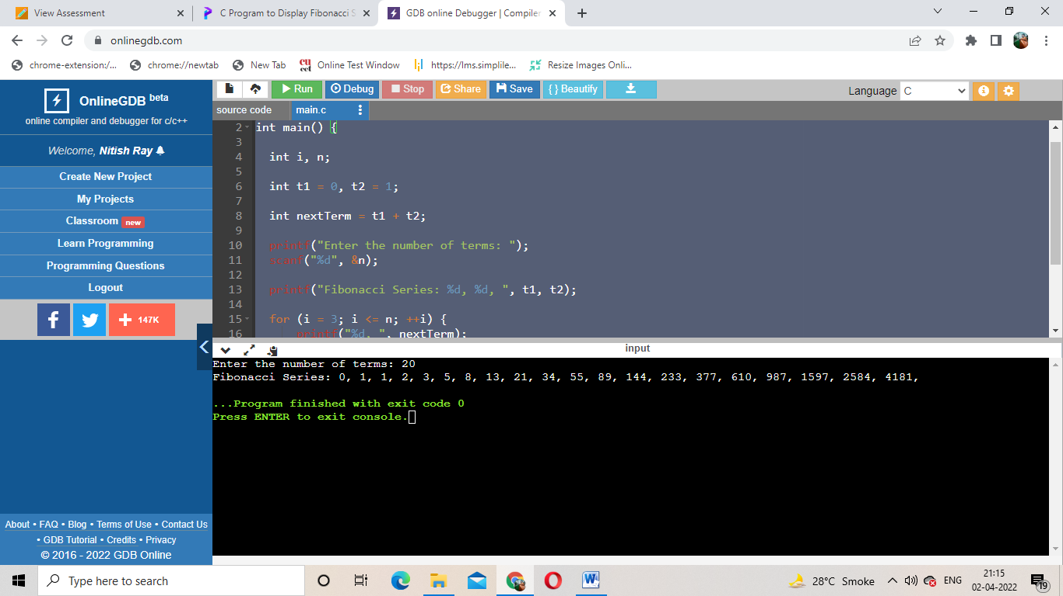

2.WAP to find Factorial of a number.

#include <stdio.h>

int main() {

int n, i;

unsigned long long fact = 1;

printf("Enter an integer: ");

scanf("%d", &n);

if (n < 0)

printf("Error! Factorial of a negative number doesn't exist.");

else {

for (i = 1; i <= n; ++i) {

fact *= i;

}

printf("Factorial of %d = %llu", n, fact);

}

return 0;

} Bottom of Form

Output of a program

